**PIZZA SALES SQL QUERIES**

# **KPI’s**

1. **Total Revenue:**

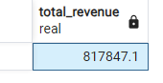SELECT SUM(total_price) AS "Total_Revenue" FROM pizza_orders;

1. **Average Order Value:**

SELECT ROUND(CAST(SUM(total_price) / COUNT(DISTINCT order_id) AS NUMERIC),2) AS “AOV” FROM pizza_orders;

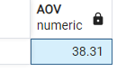

1. **Total Pizzas Sold:**

SELECT SUM(quantity) AS "Total_Pizzas_Sold" FROM pizza_orders;

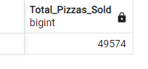

1. **Total Orders:**

SELECT COUNT(DISTINCT order_id) AS "Total_Orders" FROM pizza_orders;

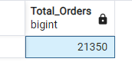

1. **Average Pizza Per Order:**

SELECT ROUND(CAST(CAST(SUM(quantity) AS DECIMAL(10,2)) / COUNT(DISTINCT order_id) AS NUMERIC), 2) AS "APpO" FROM pizza_orders;

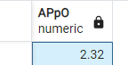

# **CHARTS**

1. **Daily Trend:**

SELECT TO_CHAR(order_date, 'Day') AS order_day, COUNT(DISTINCT order_id) AS Total_orders  
FROM pizza_orders  
GROUP BY 1

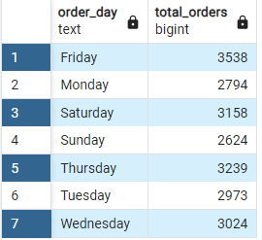

1. **Hourly Trend:**

SELECT TO_CHAR(order_time, 'HH24') AS order_Hour, COUNT(DISTINCT order_id) AS Total_orders  
FROM pizza_orders  
GROUP BY 1  
ORDER BY 1

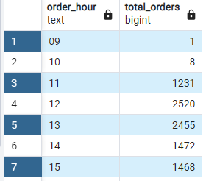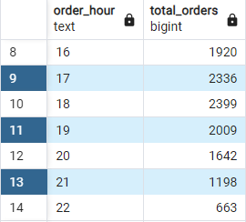



1. **Percentage and Sum of Sales by Pizza Category**

SELECT pizza_category, ROUND(CAST(SUM(total_price) * 100 / (SELECT SUM(total_price)FROM pizza_orders) AS NUMERIC),2) AS PCT,  
SUM(total_price) AS Total_sales  
FROM pizza_orders  
GROUP BY 1

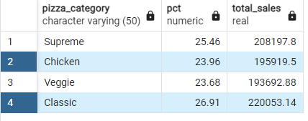

1. **Percentage and Sum of sales by Pizza Size**

SELECT pizza_size, ROUND(CAST(SUM(total_price) * 100 / (SELECT SUM(total_price)FROM pizza_orders) AS NUMERIC),2) AS PCT, SUM(total_price) AS Total_sales  
FROM pizza_orders  
GROUP BY 1

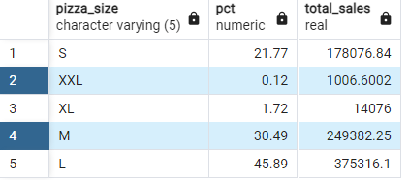

1. **Top 5 Best Seller Pizzas**

SELECT pizza_name, ROUND(SUM(total_price))  
FROM pizza_orders  
GROUP BY 1 ORDER BY 2 DESC  
LIMIT 5

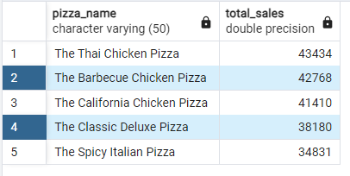

1. **Bottom 5 Worst Seller Pizzas:**

SELECT pizza_name, ROUND(SUM(total_price))  
FROM pizza_orders  
GROUP BY 1 ORDER BY 2  
LIMIT 5

